Food monitoring and early warning

Abstract:

When the flood came, the floods affected both individuals and communities, and they had social, economic, and environmental consequences. So we're designing that kind of system that gets floods before the flood comes. The purpose of the flood warning is to detect and predict flood events so that the public can be informed in advance. Thanks to flood warnings, the effects of major floods can be reduced and flood protection can be strengthened.

The warning system will monitor nearby dams, rivers and collect data i.e. water level in the river and river flow rate in relation to floods and the surrounding environment from different sensors. There are three main components of this program. The first part of the system is to detect the water level using the ultrasonic sensor and the water flow rate obtained using the flow sensor as well as the temperature and humidity using the DHT11 sensor and the rain detection by Rain Sensor. The second part of the system sends data to the Thing speak cloud and the third part of the system receives the data from the cloud and displays it in the valley again when a flood situation occurs and an announcement is made to this.part 3

Introduction

Floods can also occur in rivers if the flow rate exceeds the capacity of the river channel, especially in curves or river channels. Floods often cause damage to homes and businesses when they are in floodplains. Although river flood damage could be eliminated by staying away from rivers and other water sources, people traditionally lived and worked along rivers because the area was generally flat and fertile and because the rivers provided easy travel and access to trade and industry. The flood system is a system that considers various aspects of the environment, including water quality, flow rate, temperature and humidity and precipitation. In order to collect data for natural objects the system contains various sensors that collect individual parameter data and send it to the Thing speak cloud. In the cloud data will be analyzed and produce different results. Ku type of graphs. The first sensor is an ultrasonic sensor that measures the distance to the target by measuring the time between output and receiver.

IOT-based Flood Monitoring Techniques

There are different models from some of the existing research that is based on different flood predicting methods which highlight the importance of implementing different approaches in tackling floods. These models use WSNs to build energy efficient monitoring and early alert systems. These models can support in designing of an efficient system to predict and prevent damages caused by floods [6].

Monitoring of Air Quality using Smart Sensors

A smart sensors network for monitoring indoor and outdoor air quality was designed by Postolache et al. in 2009 [7]. They installed nodes of some of the sensors inside rooms which consisted of sensors such as tin dioxide connected to the central unit through hardwires or wirelessly [8]. For the accuracy of the result, the concentration of gas in the temperature and humidity is measured. In order to compensate for the influence of the above measurements, they applied MISO neural network (NN) which is based on multiple inputs single output. IEEE 802.11 (Wi-Fi) technology was used for communication between sensors.

Early Flood Warning Flood Detection using WSN :

An early detection of flood system was implemented by Basha et al. [12] by means of a short description of sensor networks in Hondurasi meant for the people who are at risk of getting affected by the flood [12]. It included the analysis detailing the significance of sensor networks, available operational applications, and their lower cost in developing countries. The issues pertaining to the detection of floods and cautioning people in the events of disasters were discussed since it can turn into a complex situation. After in-depth analysis, a solution was proposed that uses WSNs. This solution contains four different categories such as flood prediction, notification to the authorities, alerting the community, and evacuation of people. The proposed solution was validated by conducting various experiments. The tests were carried out for different communication ranges such as 144 MHz radio usability. The testing activity requires US antenna towers with line-of-sight for reliable communication in the air available between sensors at those ranges. According to them, sensor network technology could be the best way to prevent damage by detecting floods in developing countries.

An early flood warning system described the architecture and deployment strategy to meet the requirements. It permits enhancing the forecasting capability of the system using model-driven control. The design was created in Honduras with its utilization to detect and analyze the flood forecast. An integrated form of the forecasting technique that includes network design and testing of the attached components was utilized by the developer of this system. By deploying the system on the banks of the river in Massachusetts, they achieved a successful outcome in the field examinations. According to the framework, a very unique heterogeneous communication system was utilized by setting sensors over the river basin. These sensors could read real-time data and auto-monitor to adjust their readings if required. These readings help in estimation techniques to address disasters such as floods.

An early flood warning system described the architecture and deployment strategy to meet the requirements. It permits enhancing the forecasting capability of the system using model-driven control. The design was created in Honduras with its utilization to detect and analyze the flood forecast. An integrated form of the forecasting technique that includes network design and testing of the attached components was utilized by the developer of this system. By deploying the system on the banks of the river in Massachusetts, they achieved a successful outcome in the field examinations. According to the framework, a very unique heterogeneous communication system was utilized by setting sensors over the river basin. These sensors could read real-time data and auto-monitor to adjust their readings if required. These readings help in estimation techniques to address disasters such as floods.

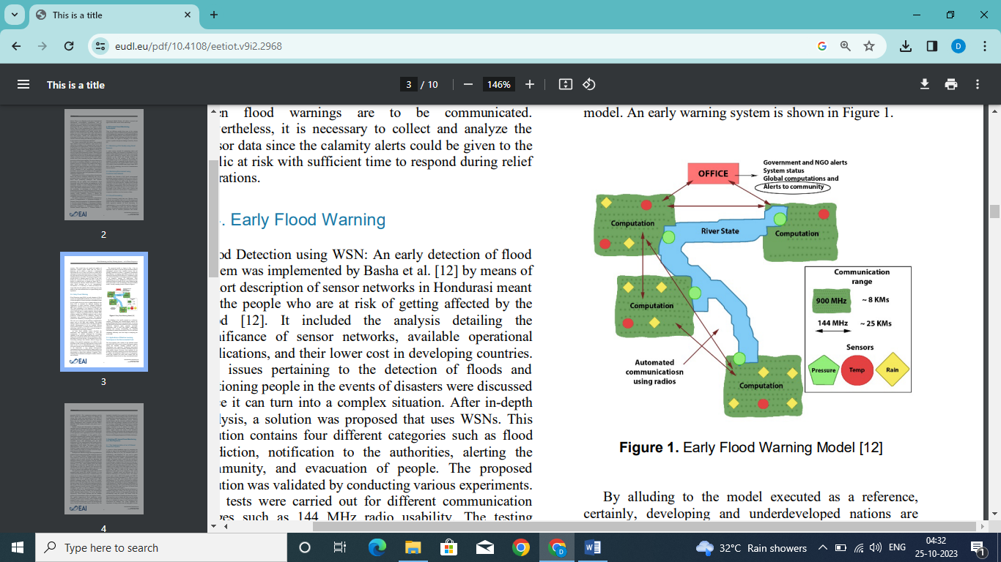

Possibility of IOT-based Flood Monitoring with Satellite Images

The Sentinel’s SAR data provides the region's specific geographical coordinates. These details help in flood mapping and analyzing the situation more precisely [27]. The SAR images are unaffected by the atmospheric conditions when downloaded. The SAR sensors have their own source of illumination [28]. The data provided by the SAR images is efficient and can distinguish the water body and land areas. The SAR satellite images are available in Standard Archive Format for Europe (SAFE) format with the well-defined resolution-based level 1 data generally as a Ground Range Detected (GRD) product. They are in Full resolution, High resolution, and Medium resolution format† . This satellite data processing supports classifying flood-prone areas and monitoring them. Further, it will help in creating a robust flood monitoring system. By implementing various ML algorithms such as supervised Random Forest (RF), K-Nearest Neighbor (KNN) classification, and K-Means unsupervised classification methods on the processed SAR data, the satellite imagebased observation of the distinctive water, urban, vegetation, and bare soil regions of flood-prone regions can be identified [29].

In Assam’s Kaziranga National Park (KNP), different types of applications for flood mapping and monitoring have been generated using Geographical Information systems (GIS) and Remote sensing methods. A distinct set of inundated and highly moisturized cloud-covered areas is available as SAR data. The Sentinel-1 series satellite data have been used to record flood levels and their severity which has helped in taking many important decisions [30]. In 2017, the dual-polarized Sentinel-1 SAR data and Landsat OLI data of KNP over unsubstantiated classification has been utilized in the analysis of spatiotemporal flood levels. In July and August 2017, the SAR images provided data on two flood waves. It was observed that the second wave had a higher intensity that had inundated huge regions. This SAR data was extremely helpful in real-time flood inundation mapping and monitoring. The SAR data is reliable as it is extracted from Sentinel’s all-weather supply of imagery. Hence, this can be widely used to monitor any specific region from time to time repeatedly.

Conclusion

IoT sensors-based flood monitoring systems tend to be lower cost, consistent and portable. However, when there are large areas, these systems are not recommended due to the fact that every sensor is generally invigorated by a vitality restricted battery. This paper reviewed and clarified different ecological and flood monitoring systems and various communication technologies that support enhancing the detection of viable floods and identifying cautioning issues. Further, these systems that are having highly reliable sensors with powerful IoT cloud platforms can be fundamentally utilized for large-scale environmental monitoring, and flood prediction and prevent damage caused by it. Even though the methodology of utilizing IoT in flood monitoring is not extensively explored at this point, we will see a colossal utilization of IoT and some new advancements in the near future. For example, AI and 5G techniques meet up for the prediction of floods as well as other natural calamities. The use of satellite images could be very helpful in flood monitoring as they help to keep an eye on the water bodies and the change in their behaviour from above. Some researchers have utilized data based on Google Maps to build a detection model. GSM modules also have been used in different ways similarly. Close consultation with hydrologists and learning machine-learning algorithms can further support building efficient monitoring and alert system. In the future, the usage of SAR data from the Sentinal-1 satellite is an added advantage in handling rescue operations and damage assessments based on data before and after floods. The wireless sensors can help in gathering flood related data by creating a database for further analysis. As a recommendation, there is a tremendous opportunity to explore the combination of IoT systems and SAR data to classify the images from floodprone areas and develop robust and secure Flood monitoring and early warning system.

Declaration

This manuscript has not been submitted to, nor is under review at, another journal or other publishing venue.